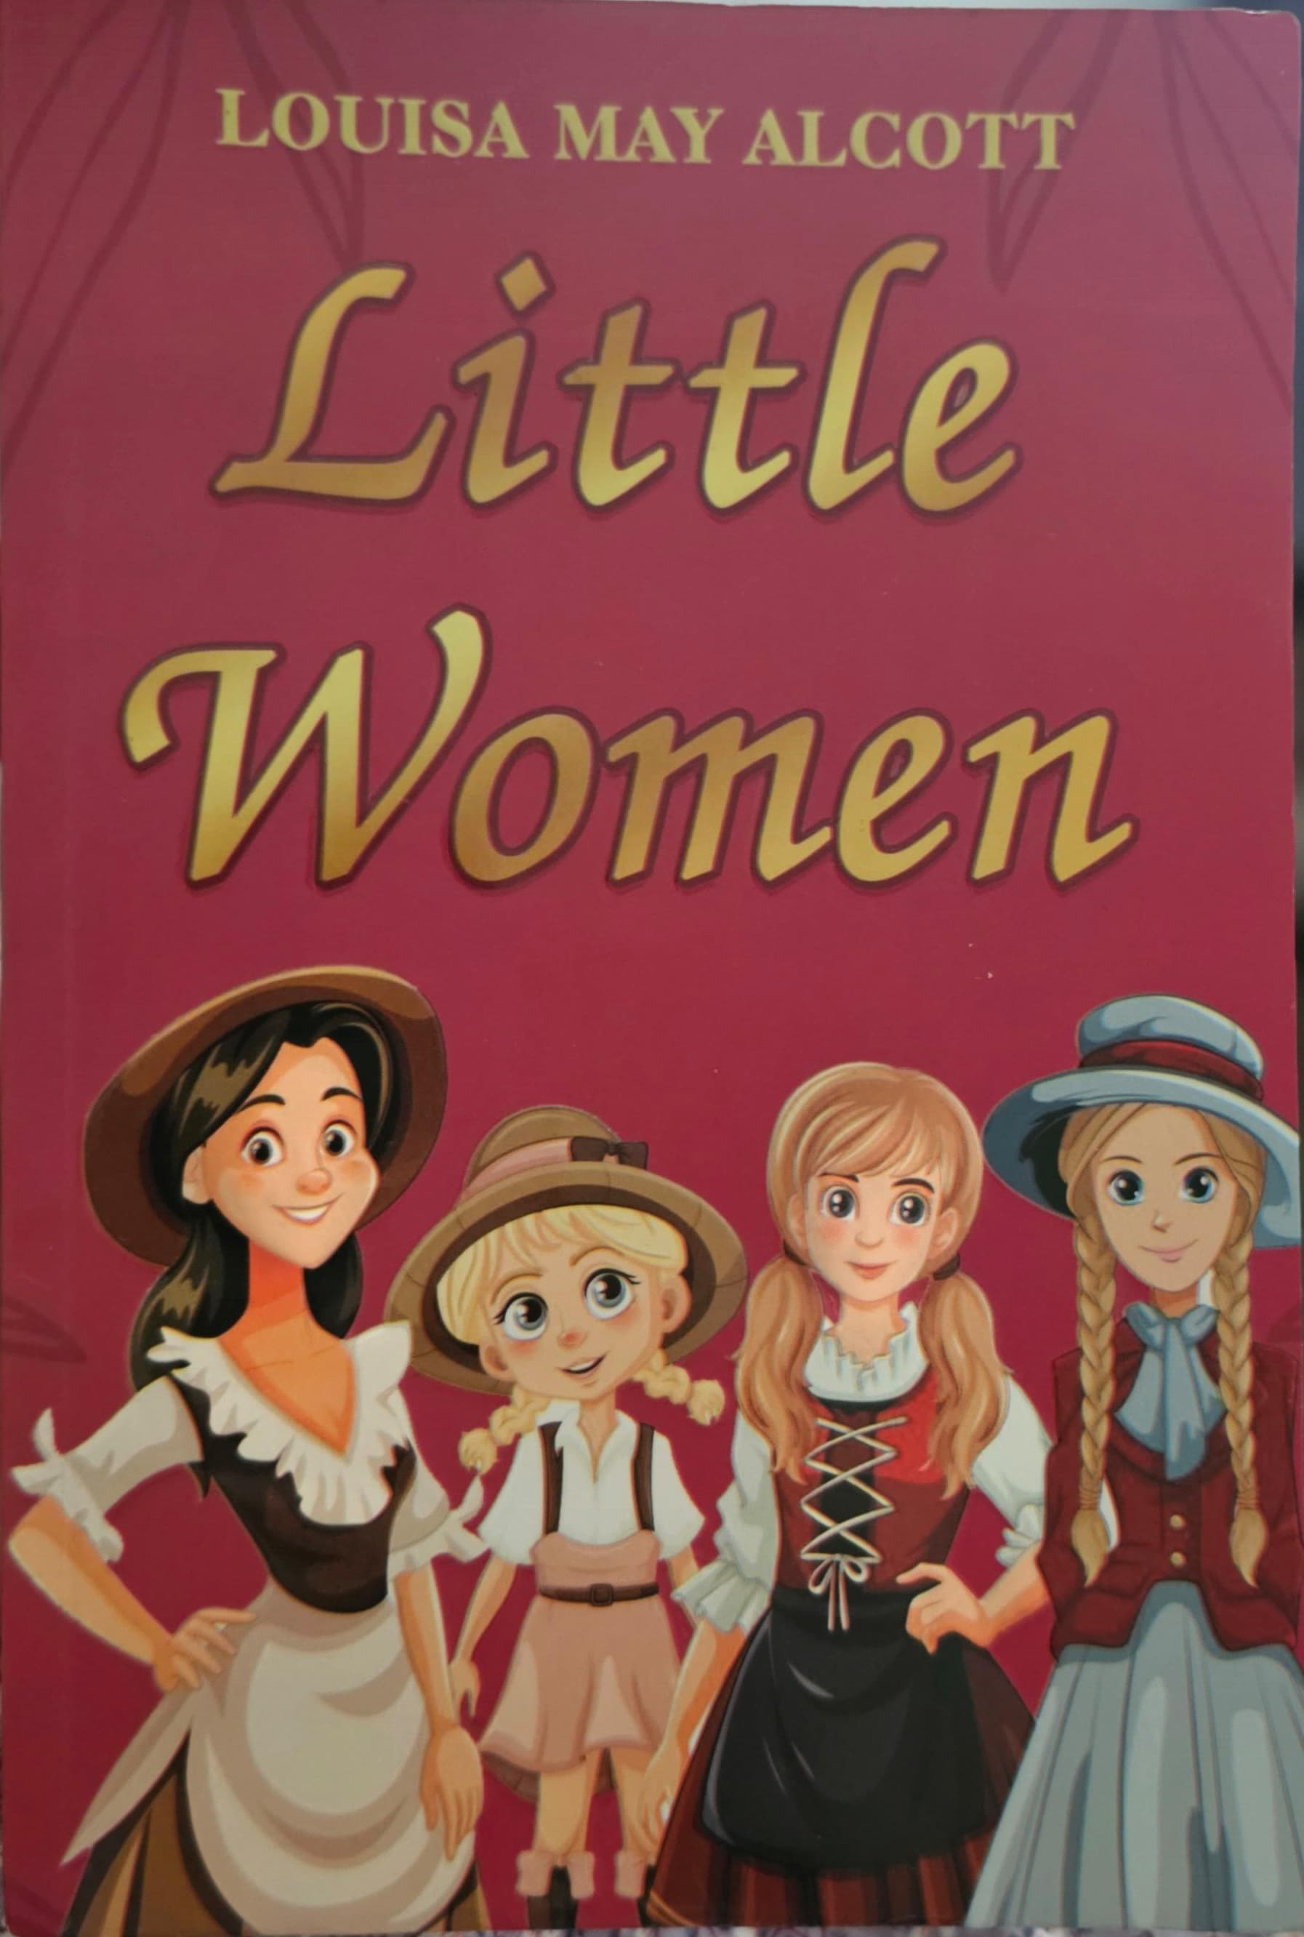 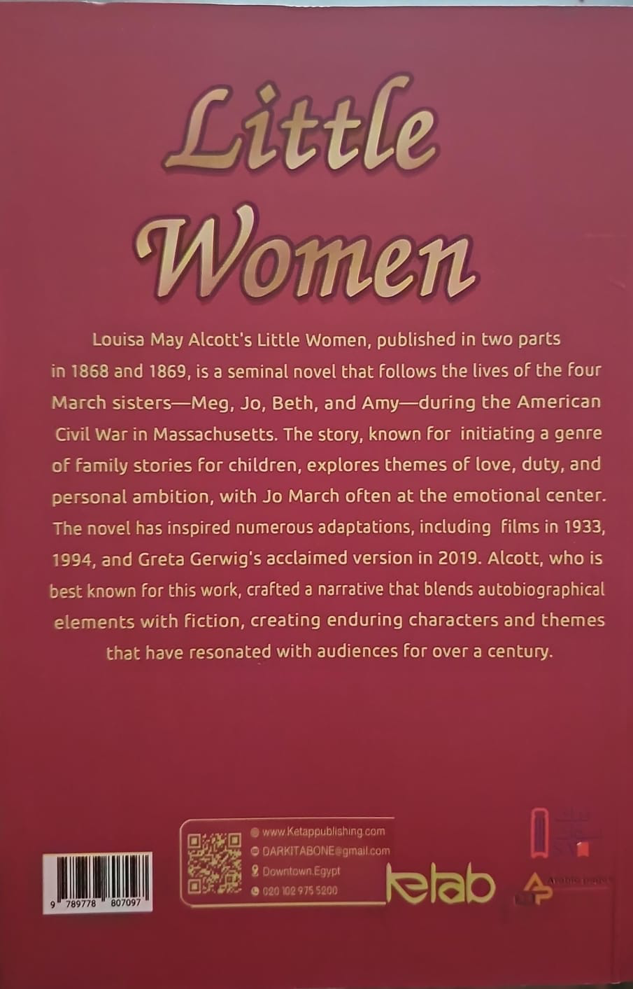

**Short Biography: Louisa May Alcott**

Louisa May Alcott was born on **November 29, 1832**, in **Germantown, Pennsylvania, USA**. She grew up in a poor but very loving family. Her father, **Amos Bronson Alcott**, was a teacher and philosopher, while her mother, **Abigail May Alcott**, was strong, caring, and very supportive of her daughters.

Louisa had three sisters: **Anna, Elizabeth, and May**. Together, they inspired the characters of Meg, Beth, and Amy in her most famous novel, *Little Women*. Louisa herself was very much like **Jo March** — independent, strong-willed, and full of dreams of being a writer.

The Alcotts did not have much money, and Louisa had to work hard from a young age. She worked as a seamstress, teacher, governess (a teacher for children in a private home), and even as a nurse during the **American Civil War**. These experiences gave her a deep understanding of life, family, and sacrifice, which later appeared in her books.

In 1868, Louisa published *Little Women*. The story was based on her own family and their struggles, joys, and dreams. The book became very popular, and readers around the world connected with the March sisters’ adventures. Louisa went on to write other novels like *Little Men* and *Jo’s Boys*, but *Little Women* remained her most beloved work.

Louisa believed in equality, independence, and women’s rights. She never married, choosing instead to focus on her writing and her family. She became one of the first women in America to register to vote in a local election, showing her commitment to women’s voices being heard.

She passed away in **1888**, just two days after her father’s death. But her legacy lives on. Today, millions of readers still enjoy *Little Women*, and Louisa May Alcott is remembered as a writer who celebrated family, love, and the power of women to follow their dreams.

**✏️ Fact Sheet: Louisa May Alcott**

**Name:** _____________________________________

**Born:** _____________________________________

**Died:** _____________________________________

**Family:**

* Father: ____________________________________
* Mother: ____________________________________
* Sisters: ___________________________________

**Childhood & Influences:**

**Jobs She Did Before Writing:**

**Famous Works:**

**Why She’s Famous:**

**Connection to *Little Women*:**

* Which sister is like Louisa?
* What family events inspired the story?
* What new hard words did you learn from this text? List them down with meanings.